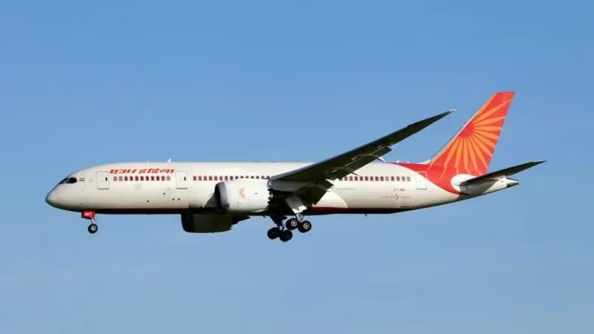
LightRocket via Getty Images
Image caption,An Air India Boeing 787 Dreamliner seen in Copenhagen

  - Author,Nikita Yadav
  - Role,BBC News, Delhi
- 19 June 2025
One of the engines of the Air India plane that crashed last week was new, while the other was not due for servicing until December, the airline's chairman has said.
In an interview with an Indian news channel, N Chandrasekaran said that both engines of the aircraft had "clean" histories.
"The right engine was a new engine put in March 2025. The left engine was last serviced in 2023 and due for its next maintenance check in December 2025," he told Times Now channel.
At least 270 people, most of them passengers, were killed last Thursday when AI171, a London-bound Boeing 787-8 Dreamliner, crashed less than a minute after taking off from Ahmedabad airport in western India.
Investigators are now sifting through debris and decoding recorded flight data and cockpit audio - from the aircraft's black boxes which have been found - to reconstruct the flight's final moments and determine the cause of the incident.
"There are a lot of speculations and a lot of theories. But the fact that I know so far is this particular aircraft, this specific tail, AI171, has a clean history," Mr Chandrasekaran said, cautioning people against jumping to conclusions.
"I am told by all the experts that the black box and recorders will definitely tell the story. So, we just have to wait for that," he added.
Kishore Chinta, a former investigator with India's Aircraft Accident Investigation Bureau, told the BBC that the condition of an aircraft engine is not necessarily linked to its age - particularly in the case of the Genx-1B engines used on the Boeing 787-8.
"The age of the engine has no bearing on the health of the engine, especially for the Genx-1B engines," Mr Chinta said. In other words just because an engine is new, does not necessarily mean it is healthy, or vice versa.
Unlike older models, the Genx-1B engines, which are made by GE Aerospace, don't follow a fixed overhaul or maintenance schedule. Instead, they are equipped with a system called the Full Authority Digital Engine Control or FADEC that continuously monitors engine health and performance. The decision to service or replace the engine is based on this data and physical inspections.
However, Mr Chinta pointed out that certain components of the engine, known as Life Limited Parts (LLPs), still have a fixed lifespan typically between 15,000 and 20,000 cycles.
"Every start and switch-off of the engine counts as one cycle," he explained.
Separately, the airline said that inspections have been completed on 26 of its 33 Boeing 787-8 and 787-9 aircraft, all of which have been "cleared for service".
India's aviation regulator had ordered additional safety checks on Air India's Boeing 787 fleet after the deadly crash as a "preventive measure".

MCQs – Questions Only
- What was the flight number of the crashed aircraft?
A. AI173
B. AI171
C. AI707
D. AI187
- Where was the AI171 flight headed to?
A. New York
B. Delhi
C. London
D. Dubai
- What type of aircraft was involved in the crash?
A. Airbus A380
B. Boeing 737 MAX
C. Boeing 787-8 Dreamliner
D. Airbus A320
- When did the crash occur?
A. On a Monday
B. Last Thursday
C. In January 2024
D. On Christmas Eve
- How many people were killed in the crash?
A. About 100
B. Over 300
C. At least 270
D. Less than 100
- When was the left engine of the crashed aircraft last serviced?
A. March 2024
B. December 2025
C. March 2025
D. 2023
- What monitoring system do Genx-1B engines use?
A. AUTOENG
B. FADEC
C. GEMS
D. ENTRACK
- Who manufactures the Genx-1B engines?
A. Airbus Aerospace
B. Rolls-Royce
C. Pratt & Whitney
D. GE Aerospace
- What does each engine cycle refer to?
A. A full journey
B. An hour of flight
C. One takeoff and landing
D. Every start and switch-off
- According to the passage, what is true about new aircraft engines?
A. They are always healthy
B. Age doesn’t always determine engine health
C. New engines are avoided
D. They don’t need servicing
- What has India’s aviation regulator done after the crash?
A. Banned all Boeing aircraft
B. Grounded all domestic flights
C. Ordered extra safety checks on Boeing 787s
D. Cancelled Air India’s license
- How many of Air India’s Boeing 787 aircraft have been cleared for service after inspection?
A. 33
B. 26
C. 7
D. 30

Answers
- B. AI171
- C. London
- C. Boeing 787-8 Dreamliner
- B. Last Thursday
- C. At least 270
- D. 2023
- B. FADEC
- D. GE Aerospace
- D. Every start and switch-off
- B. Age doesn’t always determine engine health
- C. Ordered extra safety checks on Boeing 787s
- B. 26

